**Project Design Phase**

**Solution Architecture**

|  |  |
| --- | --- |
| Date | 26 June 2025 |
| Team ID | LTVIP2025TMID53148 |
| Project Name | ResolveNow: Your Platform for Online Complaints |
| Maximum Marks | 4 Marks |

**Solution Architecture – ResolveNow**

The solution architecture for **ResolveNow** bridges real-world complaint handling challenges with a scalable, tech-driven system. It ensures the platform is structured, user-centric, and capable of growth.

**Goals of the Architecture:**

* Deliver the **best-fit technology solution** for managing and resolving user complaints.
* **Visualize and describe** the system's components, interactions, and behaviors to all stakeholders.
* **Define core features**, development phases, and technical requirements for each module.
* Ensure the solution is **modular, scalable, and maintainable** for future upgrades or integrations.

**Solution Architecture Diagram:**

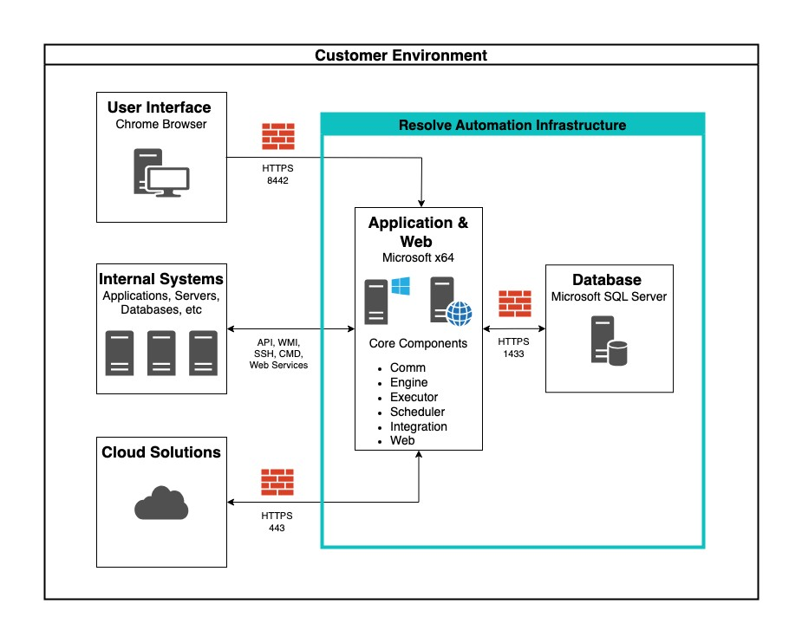

**Figure 1**: Architecture and Data Flow of the ResolveNow Application

**Key Architecture Components:**

**Layer Technologies / Responsibilities**

Built using **React.js**, styled with **Material UI** and **Bootstrap** for

**Frontend** responsive design.

Developed in **Node.js** with **Express.js**, responsible for APIs, routing,

**Backend**

authentication, etc.

**MongoDB** for storing users, complaints, chats, and feedback in

**Database**

structured collections.

**Authentication** **JWT** based secure login for users, agents, and admins.

Enabled via **Socket.IO** to allow users and agents to communicate on

**Real-time Chat**

complaint threads.

**Email/SMS**

Uses **Nodemailer** and optionally **Twilio** for notifications and updates.

**Alerts**

Frontend and backend can be deployed on **Vercel**, **Render**, or **MongoDB**

**Hosting**

**Atlas** (cloud DB).

**Reference**

**AWS Blog – Voice Applications in Clinical Research (Architecture and Design Considerations)**

[https://aws.amazon.com/blogs/industries/voice-applications-in-clinical-research-poweredby-ai-on-aws-part-1-architecture-and-design-considerations/](https://aws.amazon.com/blogs/industries/voice-applications-in-clinical-research-powered-by-ai-on-aws-part-1-architecture-and-design-considerations/)